

MS Word Training - Session 1: Part 2

Page Layout Concepts
Version: 1.0
February 2009
Copyright Information:
This document is the sole property of AIG Inc. All rights reserved. No part of this document may be reproduced, stored in a retrieval system, translated, transcribed, or transmitted in any form or by any means, without the prior written permission of AIG Systems Solutions (AIGSS).
Document Information
S.No | Document Title | Base Version No. | Author | Contact Email ID | Date Of Release
1 | MS Word Training - Session 1: Part 2 | 1.0 | Deepika Datta | deepika.datta@aig.com | Feb’09
Revision History
S.No | Version No. | Date Of Release | Author (s) | Affected Section(s) | History of Changes | Approver

Table of Contents
1 Page Layout Concepts 4
1.1 Margins 4
1.1.1 Changing margins using Page Setup 4
1.1.2 Changing margins using the ruler 4
1.2 Paper size 5
1.3 Page numbering 6
1.3.1 Inserting page numbers 6
1.3.2 Formatting page numbers 6
1.4 Page breaks 7
1.4.1 Inserting a page break 7
1.4.2 Removing hard page breaks 7
1.5 Basic page Numbering 7
1.5.1 Inserting page numbers 7
1.5.2 Formatting page numbers 8
1.5.3 Removing page numbers 8
1.6 Headers and footers 8
1.6.1 Creating a header and/or footer 8
1.6.2 Editing or removing a header or footer 9

Page Layout Concepts

Margins
When you start a new document, there are pre-set margins for the top, bottom, left and right sides of the page. The default values are 3.17cm (1 ½") for the left and right margins and 2.54cm (1") for the top and bottom margins. Margins can be applied to either the whole or to a part of the document such as a section. Sections are beyond the scope of this course and are covered on the Managing Long Documents course.

Changing margins using Page Setup
- On the File menu, click Page Setup. The Page Setup dialog box appears.
- Click on the Margins tab.
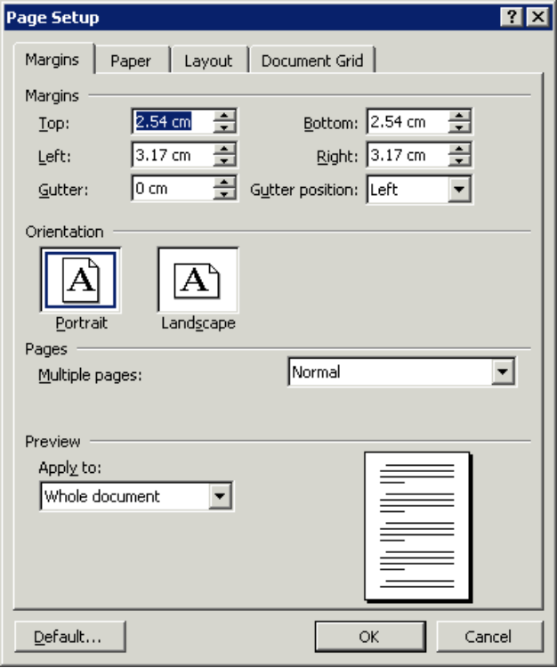
Margins tab
Enter a new value for the margin.
Use the buttons to increase/ decrease the margin.
Select the part of the document to which you want your new margin settings to apply.
Change paper orientation here.
- Select the existing entry for the margin(s) you wish to change.
- Type a new value in the text box or use the buttons to the right-hand side of the text box (see the figure above) to increase or decrease the current setting.

Helpful hint:
To navigate between the text boxes press the Tab key to move from one to the next, or position the cursor in the next field using the mouse. Do not press the ↵ key between selections, as this will close the dialog box.

Changing margins using the ruler
It is possible to change margins directly using controls on the horizontal and vertical rulers. You must be in Page Layout view and both rulers must be visible.
- Position the insertion point against the left/right margin on the horizontal ruler (top/bottom margin on the vertical ruler) and notice as the mouse pointer changes shape to a double-headed arrow.
Left margin
Right margin

- Click and drag the double-headed arrow shape along the ruler. The shaded area on the ruler increases/decreases and defines the new left/right margins.
If you hold down the Alt key as you drag, the measurement is displayed on the ruler.
Helpful hint:
When attempting to adjust the margins on the ruler, take care to drag the pointer only when you see the double-headed arrow. This will minimise the risk of inadvertently adjusting any indent or tab markers.

Paper size
- On the File menu, click Page Setup. The Page Setup dialog box appears
- Click on the Paper tab.
- In the Paper Size list select an appropriate paper size e.g. A4 and click OK.
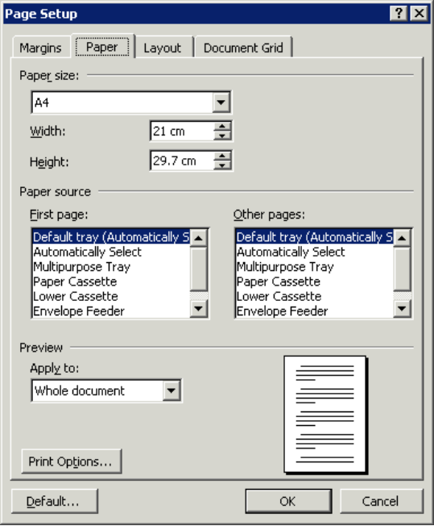
Paper tab
Select a paper size here.
Select the part of the document to which you want your new settings to apply.

Page numbering
Page numbers can be inserted into any document, at the top or bottom of a page. When a page number is inserted, a Field is placed in the document which automatically controls the page numbering and ensures the correct page number is inserted and updated as the document changes.
Depending on the view selected, page numbers may not be visible on the screen. To view the page numbers on the page, you must switch to Print Layout or Normal view.
There are two ways to add page numbers to your document:
- On the Insert menu, click Page Numbers.
- From the View menu, click Header and Footer.
The first method is useful if you only want to add a page number and format it. The second method enables you to add other information along with the page number in the header or footer. (This option is covered on the Getting more from Word course.)

Inserting page numbers
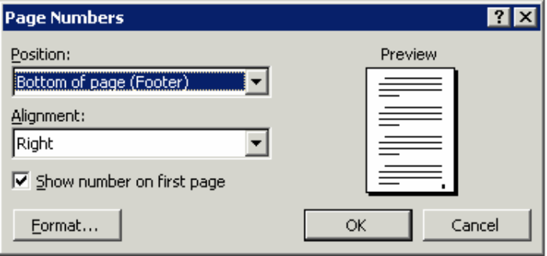
- On the Insert menu, click Page Numbers.
Select Position to place your page numbers.
Select this to number your first page. Deselect it to suppress page numbering on the first page.
Select the alignment of the page numbering here.
The preview will update to reflect your choices.
- The Page Numbers dialog box is displayed (see below).
- Choose where to position the page numbering: in the Position box, click either Bottom of page (Footer) or Top of page (Header).
- In the Alignment box, click either Left, Centre, Right, Inside or Outside. Notice that as you change the settings the Preview is updated.
- Click to select/deselect as appropriate in the Show numbers on first page check box.

Formatting page numbers
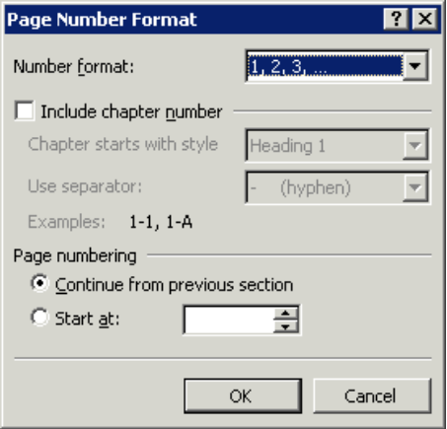
- Click on the Format button in the Page Numbers dialog box.
Select your number format here.
You can change the starting number here.
- The Page Number Format dialog box appears:
- In the Page Number Format box, click on the required format. Character formats and Roman numerals are included in the options.
- In the Page numbering area, control the numbering in the document by choosing the appropriate option.
- When the required formats have been selected, click OK to return to the Page Numbers dialog box and OK to finish.

Page breaks
Word automatically places page breaks in a document when you type more text than can fit on a single page. This type of page break is called a soft page break. Sometimes you will want to force a new page before your text reaches the bottom of a page. This can be achieved by inserting your own page break, called a hard page break.
Helpful hint:
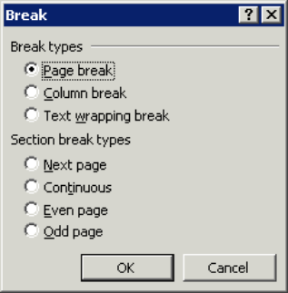
Avoid pressing ↵ multiple times to start a new page as any modifications you make to the document may affect the page layout.

Inserting a page break
Position the insertion point in the document where you want the break to appear.
- On the Insert menu, click Break. The Break dialog box appears.
- Click Page Break and then click OK.
There is also a keyboard shortcut: Ctrl+Enter.

Removing hard page breaks
The easiest way to remove a page break is when the page break code is visible in the document i.e. when viewing a document in Normal view, or when the Show/Hide button is activated.
- Switch to Normal view.
A fine dotted line will appear across the page indicating the presence of a user-inserted (or hard) page break.
- Click on the Page Break line to select it.
- Press Delete. The page break is deleted and any text below the break in the document will move up as the pages are updated.

Basic page Numbering
Page numbers can be inserted into any document, at the top or bottom of a page. When a page number is inserted, a field is placed in the document which automatically controls the page numbering and ensures the correct page number is inserted and updated as the document changes. Depending on the view selected, page numbers may not be visible on the screen. To view the page numbers on the page you must switch to Print Layout view.
There are two ways to add page numbers to your document: on the Insert menu click Page Numbers or on the View menu click Header and Footer. The first method is useful if you only want to add a page number and format it; the second enables you to add other information along with the page number in the header or footer.

Inserting page numbers
- On the Insert menu click Page Numbers. The Page Numbers dialog box is displayed.
- Choose where to position the page numbering. In the Position box choose either Bottom of page Footer or Top of page Header.
- In the Alignment box choose either Left, Center, Right, Inside, or Outside. Notice that as you change the settings the preview is updated.
- Click to select/deselect as appropriate in the Show numbers on first page box.
Select position to place your page numbers.

Select to number your first page.

Select alignment of page numbering here.

Figure 17

Create a new
document and put the summary there

10
0

Figure 11

Click here to display formatting options –number types etc.

The preview will update to reflect your choices.

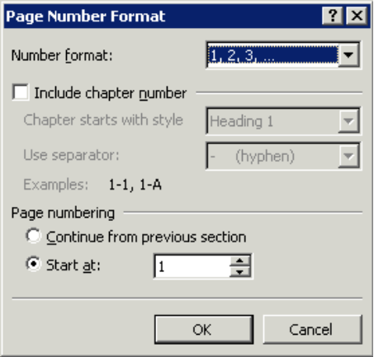

Formatting page numbers
- Click on the Format button in the Page Numbers dialog box to display the Page Number Format dialog box.
- In the Number format area, click on the required format. Character formats and Roman numerals are included in the options.
- In the Page numbering area, control the numbering in the document by choosing the appropriate option.

Removing page numbers
If you wish to remove page numbers, you will need to enter the Header/Footer view – see the next section.

Headers and footers
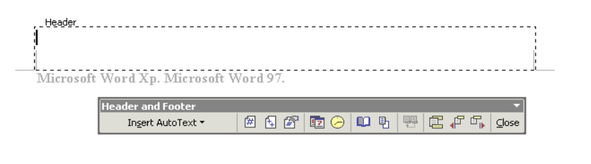
A header or footer is text (or graphics) printed at the top (header) or bottom (footer) of a page. It is usually repeated on every page in the document. This manual has a footer that includes a page number and other information. Each header and footer appears as a text box at the top or bottom of the document with its own tab settings ready for text entry. A toolbar also appears when headers and footers are activated which includes a number of buttons to facilitate working with headers and footers and make the insertion of page numbers, and other fields (such as Date and Time) a straightforward task.
The document text is dimmed when the Header / Footer area is active.
It cannot be modified from here.

The Header area is displayed ready for text entry.

Creating a header and/or footer
- On the View menu, click Header and Footer. The Header and Footer toolbar is displayed.
- Text can be entered in the header or footer area and formatting applied to it in the same way as in the main document.
Insert Number
of Pages

Insert Page Number

Insert Date

Insert Time

Switch between Header and Footer

Figure 3

Figure 3

Insert Autotext Entry
Format
Page
Number

Page Setup

Show/Hide
Document
Text

Show
Next

Show Previous

Same as Previous

- AutoText entries and fields (including page numbers) can be inserted automatically into the header/footer by clicking on the appropriate options on the Header and Footer toolbar (see above).
- Click on the Page Number button to insert page numbers.
- Click on the Switch between header and footer button to switch from one to the other.
- Click on the Close button or double-click anywhere in the main document area i.e. outside the header or footer to finish editing.

Editing or removing a header or footer
- On the View menu click Header and Footer, or double-click in the header/footer area. The header/footer box is displayed and ready to be edited. If necessary use Switch between Header and Footer to switch to the footer.
- Make any amendments as necessary.
- Click on the Close button, or double-click anywhere in the main document area i.e. outside the header or footer to finish editing.

